Constructing a Simple ArcGIS Experience Builder Site and Configuring Multiple Widget Types

With the use of this tutorial, you will be able to construct a website using Experience Builder involving some of the available widgets.

OBJECTIVES
- Create a basic Experience Builder site using a webmap containing census tract level social determinants of health data from the CDC
- Utilize a variety of Experience Builder widgets to portray the data, while providing a useful design experience to the student in the process

Requirements:
- An ArcGIS project file from Practice Exercises 7 folder titled “Experience_Builder_Tutorial” should be opened within ArcGIS, and then shared as a webmap to your ArcGIS Online account with the title “Experience_Builder_Tutorial_<YOUR INITIALS>”. Sources:
  - Tennessee_CensusTracts_SDOH layer is from CDC\ATSDR\Office of Innovation and Analytics\Geospatial Research, Analysis, and Services Program (GRASP) and was downloaded from ArcGIS ONLINE and filtered for TN tracts only.
  - CBO layer is 64 point features, primarily in the Shelby County, Tennessee area, representing community based organizations from a variety of categories.

Section 1: Initial Site Construction
ArcGIS Experience Builder is a tool designed to create web apps and pages using data, maps, and content with minimal or no coding required. It empowers its users to deliver responsive web experiences with little effort.

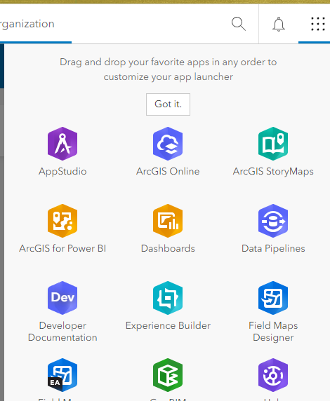
Section 1.1: Create the Experience Builder File

- Sign-in to ArcGIS Online (AGOL). Click on the dot-grid next to the username in the upper right corner of the page to access the ESRI suite of apps. Select “Experience Builder.”

- From the webpage that opens, you can select from your existing experiences or create a new one. For the sake of this tutorial, click on “+Create new” in the upper right-hand corner.

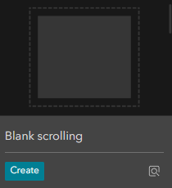
- The template page opens next. Many options are available that suit just about any purpose. Oftentimes, the “Blank Fullscreen” template is chosen. However, this option limits the vertical size of the page and the amount of content that can be included. Select the blue “Create” button associated with the “Blank scrolling” template (NOTE: feel free to mouse-over the template options to view descriptions of their intended use).

- Your new Experience Builder file has been created (but not yet published). If the “Getting Started” tour window opens, feel free to proceed through it or to skip it. Click on the title “Untitled Experience 1” on the upper left corner of the page and change your Experience Builder site’s title to whatever you desire. Notice that next to the title it says “Draft.” This will remain the case until you publish the site later.

Section 1.2: Format the Page

- On the left side of the webpage, you will see the following menu bar:

Insert Widget
Page
Data
Utility Services
Theme
General
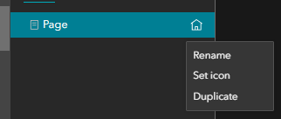
- Select the “Page” option. Notice there are now two tabs available with this selection, “Page” and “Window.” Hover over the title of the only page listed, titled “Page.” Click on the three option dots and select “Rename.” Change the title to an appropriate name.

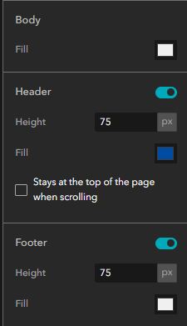

IMPORTANT NOTE: When changes are made to your site, make sure to click on the “Save” icon near the upper right hand corner of the screen periodically to save your edits/changes. However, upon saving, the option to undo is reset. Even when saving, the site still is not “published.”
- When a page, or window, or widget is selected in the left-side pane, a corresponding pane opens on the right-side, providing the opportunity to adjust data sources, formatting, and connections between content, depending on what is selected. With your Page selected in the left-side pane, toggle on both “Header” and “Footer.”

- You now have the opportunity to adjust the height and colors of both the header and footer. In the header group, change the height to 120 pixels. Because the default footer color is white, it might be difficult to realize it is toggled on. Change the color by clicking on the box to the right of “Fill” in the footer group of settings. For the time being, chose one of the Standard Colors that are presented. The background color of the page itself can be set as well. In the Page pane on the right-side, click the white box next to “Fill” in the “Body” group. Try several different colors until the desired one is found.

Remember to save your work periodically.
NOTE: You will be submitting your results of these “tasks” at the end of this tutorial by providing the URL of your published Experience Builder site.

Section 1.2 Task: Select “Theme” on the far-left toolbar. Explore different themes.

Section 1.3: Image and Text Widgets

- Later, you will be adding a WebMaps to your site that has social determinants of health data for each census tract in Tennessee. Let’s customize the header in preparation for that. Whatever content is contained in the header on one page automatically appears on every page (the same is true with footers). Let’s add an image and some text to the header. Hover your mouse over the header and click on “Edit Header.” When content is added to any part of an Experience Builder site, it is done so using “widgets.” Let’s first add an Image Widget to the header.
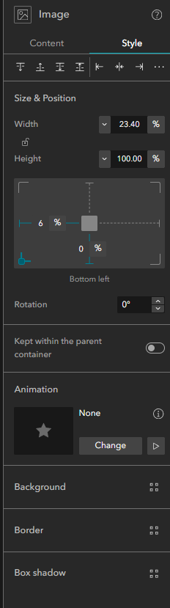
- On the menu bar on the far-left side of the site, select the “Insert Widget” option. By default, every widget that is available is shown. At the top-right of the pane, click on the search icon and type in “image.” Using your mouse, click and drag the “Image” widget into the header area. This is simply a container; you must now add the image. Since the Image Widget is still selected, the image pane appears on the right-side of the page. Images can be displayed from a URL address, or an uploaded image. Click on “select an image.”

Section 1.3 Task (a): For the sake of this exercise, find an open-source image related to health and store it locally on your computer. Click “Upload” in the “Select an Image” pane, navigate to your store image and select it. The image now appears in the Image Widget of the header.
- Each widget’s pane provides many options to customize its appearance and usage. Click on the “Style” tab in the Image Widget pane.

- The width and height of the widget can be controlled based on percentages and pixels. Click on the “%” sign next to the width value and select “px” for pixel. Vary the value for the width and see how it affects the size of the Image Widget. Do the same for the height value, until you are content with the size of the image in the header.

- The positioning of widgets can be controlled similarly, using percentages based on the total screen size or the size of the container (more on this later) that holds them, or absolute pixel values. In the image below, the box in the center represents the widget. The “%” can be clicked on and changed to pixels; the numerical value can be typed in. Also, by clicking on any of the four vertical or horizontal lines, you can determine from where the positioning is referenced.
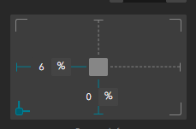
Section 1.3 Task (b): Change the positioning from the left edge to 65 pixels and determine the pixel value from the bottom edge that centers your image vertically.
- Let’s next add a descriptive text to the header. In the search box for the Insert Widget option on the left-side of the page, delete “image” and type in “text.” Drag the Text Widget into the header area and position as desired. Double click the Text Widget box and type in an appropriate title for a page that presents social determinant of health for Tennessee. Click outside of the Text Widget, but still within the header, and then click on the Text Widget once again.

Section 1.3 Task (c): Using the Text pane on the right-side of the page, adjust the font, font-size, etc. to your liking. Once again, click on the “Style” tab and adjust the size and positioning of the Text widget in the same fashion as you did the Image Widget.

- Click in the center of the canvas area to exit header editing.

Remember to save your work periodically.

Section 2: Adding Content Using Widgets

Section 2.1: The Map and Search Widgets

You will now add Map and Search Widgets to display a webmap and find locations on it. However, before doing so, it is advisable to add some layout containers for the widgets. It is best practice to use items such as the “Row” and “Column” layout containers to better control the size and position of the elements of your page as the browser window changes size and proportion.
- Go to the Insert Widget option on the toolbar on the far-left side of the page. Search for the “Row” widget. Drag the Row Widget onto the center of the canvas. It might be that this new item doesn’t fill the width of the page. That is ok; it can be adjusted later.

- Next, search for the “Map” widget. Drag the Map Widget into the Row that you previously put on the canvas. Using the sizing bars on the Map Widget, resize it to fill the entire Row Widget.


- Currently, there is no map associated with the Map Widget. Let’s change that. Previously, you uploaded the “Experience_Builder_Tutorial_<YOUR INITIALS>” webmap to AGOL. To display this map in the Map Widget, you must first make the data connection. On the toolbar on the far-left side of the page, select the “Data” option.

- Click on the blue “+Add data.” The available maps, scenes, and layers from your personal content and organization, along with ArcGIS Online and Living Atlas, should appear. Click on the “Experience Builder Tutorial” webmap and then select “done” in the bottom right-hand corner of the page. You are redirected back to the Experience Builder interface. Notice that the webmap still does not display in the Map Widget.
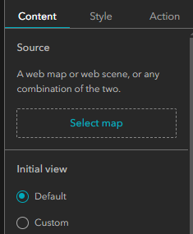
- Click on the Map Widget and then direct your attention to the Map pane on the screen’s far-right side. In the “Source” group of the “Content” tab, click on “Select Map.”

- Click on the Experience Builder Tutorial webmap’s title in the “Select Data” panel that has opened.

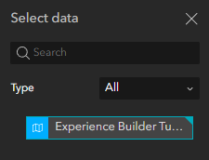

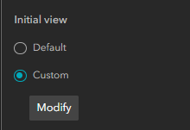

- “X” out of the “Select Data” pane. In the “Map” pane, in the “initial view” grouping, select “custom” and then click “Modify.”

- In the “Modify initial view” window that opens, use your mouse to determine the default view of your map. Click “OK” to close it. Save your work.


- Let’s get a good view of what’s been done so far. To the immediate right of the save button is the “Preview” button. Click on this…a new browser tab opens with a preview of your site.

Section 2.1 Task (a): Having previewed your site, what changes to sizes and placements should be made? Oftentimes if percentage values are used for positioning, resizing the window changes appearances in a negative way. Edit your header so that both the Image Widget and the Text Widget have positions represented by pixels rather than percentages. “Save,” “Preview,” and resize the browser, confirming the results are as desired.
Section 2.1 Task (b): In the “Tools” grouping of the Map pane, there are many available options that can be toggled for your Map Widget. Explore each option and use what you deem appropriate (NOTE: toggle off the search option, we’ll add that in a different way)

- Further down in the “Options” grouping of the Map pane is a toggle for “Enable pop-up.” Because you will display map data using several other widgets, toggle off the pop-ups.

Remember to save your work periodically.

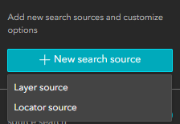
- Let’s add a search box to locate positions on the map. In the Insert Widget tool on the far-left side of the page, search for “Search.” Drag the widget directly onto the map. When this widget is selected, the Search pane appears on the far-right side of the page. Click on the blue “+New search source” button in that pane.

- In the drop-down menu, you have the choice of “Layer source” (features from a given layer can be searched) and “Locator source” (geographic locations can be found). Choose “Locator source” and click “Select utility” in the “Set locator source” pane that appears. Choose the “ArcGIS World Geocoding Service” option. Leave all the defaults intact and close the “Set locator source” pane.

- Click the “Style” tab in the “Search” pane and adjust the size and position of the widget.
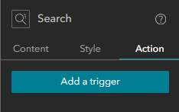
- Click the “Action” tab and then click on “Add a trigger.”

- In the “Select a trigger” pane, click on “Record selection changes.” Since we want interaction with the Search Widget and the Map Widget, under “Widgets” select “Map.” Click on “Zoom to” so that a search selection causes the map to zoom to the search location. In the “Zoom scale” grouping, check the “Custom” box. Entering a value adjusts the scale of the map that results when zooming in upon selection. Put a value of your choice in this box.

- In the “Search” pane, click “Add a trigger” again and select “Records created” in the “Select a trigger” pane. Click “Map” under “Widgets.” Select “Show on map.” This will drop a marker on the webmap when you select a location from the Search Widget. Customize the symbol by clicking on the box to the right of the word “Point.” Choose the symbology that you find appropriate.

- Save your work and click on the “Preview” button. Test out the search widget with a location.

Section 2.1 Task (c): Adjust the value for the custom zoom so that when the map zooms in after a search selection, you are content with the map extent shown.

Section 2.2: The Text Widget and Dynamic Text

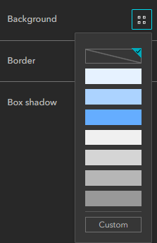
Each of the census tracts in the webmap has 9 attribute field corresponding to social determinants of health (SDOH). Let’s add a text box that displays these attributes associated with a particular census tract when it is selected in the map.
- From the Insert Widget option on the far-left side of the page, search for the Text Widget and drag it onto the canvas, to the right of the Map Widget within the Row Widget. Depending on the background color of your page, it might be difficult to view any text you include. In the Text pane on the far-right side, select the “Style” tab. Expand the “Background” section and select “Custom” at the bottom of the popup.

- Next, click the color box to the right of “Fill” and choose white for the color. Double-click within the text widget and type a suitable title for the display of the SDOH. If you now highlight your title using your mouse, you can adjust the font size, color, etc.

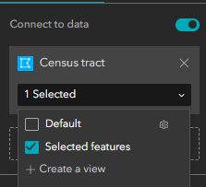
- Below the title, you will code the Text Widget to display data from a selected tract of the webmap. In the Text pane on the far-right side, select the “Content” tab and then toggle “Connect to data.” Click on “Select data” and then choose the “Census tract” layer from within the “Select data” window that opened. So that data selected from the webmap is displayed, from the drop-down menu under Census tract in the Text pane, check the “Selected features” box.

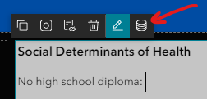
- Next, click in the Text Widget and type “No high school diploma: ” To get data from the selected census tract to display, you must access the “Dynamic content” feature above the Text Widget:

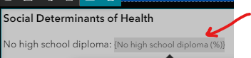
- After clicking on the dynamic content option, the Dynamic content window opens, which has three tabs. While on the Attribute tab, scroll down and click on “No high school diploma (%).” Next, click on the attribute in the Text box:

- Then, select the Expression tab in the Dynamic content window. Click on the title box, delete the title that is there and replace it with an empty space using the spacebar (You’ve just set the title to an empty space, which will be displayed in the widget when there is no map selection). At the bottom of the window, select the tools gear. Toggle on “Number formatting,” set the decimal box to 2, and the click “Insert.” Close the Dynamic content window.

- Save your work and preview the site (Note: click outside of the Text Widget before saving). In the preview, select one of the census tracts and observe that a value appears for the “No high school diploma (%)” in that census tract.

Section 2.2 Task: In the list of attributes for each census tract, there are a total of nine percentages. Repeat the above steps for the remaining eight SDOH. Then, format all of the content in the Text Widget, including the dynamic content, in an appropriate manner.

Section 2.3: The Chart Widget

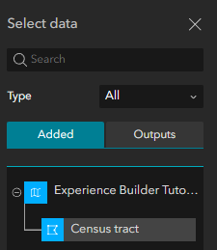
- To display the SDOH graphically, you will add a Chart Widget. From the Insert Widget option on the far-left side of the page, search for the Chart Widget. Drag a Chart Widget into the area below the Row Widget which contains the Text and Map Widgets. Using the sizing bars, increase the width of the Chart Widget to match the width of the page. In the Chart pane on the far-right side of the page, select “Select data.” In the “Select data” window, navigate to and select the “Census tract” layer.

- Back in the Chart pane, from the drop-down menu within the “Census tract” box, select “Selected features” (This will enable selections from the Map widget to have data charted). Still in the Chart pane, under “Chart type” click on “Select chart.” Choose the first of the column chart types:

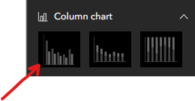
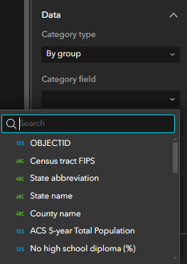
- In the “Data” grouping, still on the Content tab, of the Chart pane, select the drop-down menu for “Category field” and choose “Census tract FIPS.”

- For the “Statistics” option, select “No aggregation” from the drop-down.

- From the drop-down menu in the “Number Fields” option, check the boxes for the nine percentage SDOH attributes (NOTE: the order in which you check the boxes determines the order in which they are displayed!).

- Next, the chart must be formatted. Expand the “Series” grouping in the Chart pane. Toggle on “Data label” (this places a value at the top of bar). Click the pencil next to “No high school diploma (%).”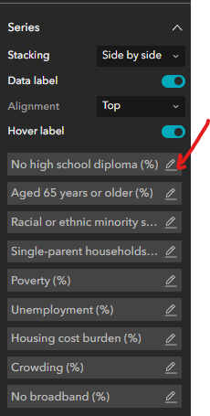
- Edit the label to something shorter. This label will appear in the chart legend, as well as when the mouse hovers over a bar. If desired, the color of the bar can also be edited.
Section 2.3 Task: Edit the title of each of the nine SDOH.

- Expand the “Axes” grouping. Select the edit pencil next to “X axis.”
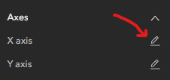

- Give your x-axis a title. Repeat for the “Y axis.”

- Expand the “General” grouping. Give your chart an appropriate title. Also, toggle on “Legend.” Explore the other “General” settings.

- By selecting the “Appearance” grouping, you can change the background color of the Chart Widget and format the text and symbol elements. Do so if you desire.

- Save your work and click on the “Preview” button. Test out the Chart Widget by clicking on a census tract on the map.

Section 3: Adding Pages and Navigation

Section 3.1: Create a New Page
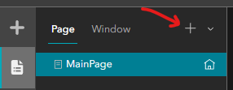
- On the toolbar on the far-left side, select “Page” from the toolbar. On the “Page” tab, click the “+” sign in the upper right corner.

- When the “Add page” window opens, select the “Scrolling page” tab, and then choose the “Blank scrolling” template. You have just added a second page to your Experience Builder site. In the Page pane on the far-right side, toggle on both the header and the footer. If you save and preview your site, you will find out that there is no way to navigate from one page to the other. Let’s change that

Section 3.2: Add a Button Widget for Navigation and Publish

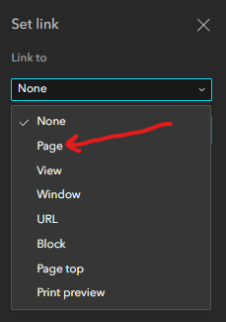
- Since you are currently on the second page, let’s add a Button Widget to the header that will switch from this page to the first when clicked. Begin by selecting “Edit header” at the top of the page. On the toolbar on the far-left side of the page, select the Insert Widget option. Search for the “Button” widget. Drag the Button Widget to the far-right side of the header. The “Quick style” window opens. This is an optional method of formatting; close it for this tutorial. In the Button pane, click on “Set link.” The “Set link” window opens. From the “Link to” drop-down menu, choose “Page.”

- From the “Select a page” drop-down menu, choose the title of the first page of your site. Click “OK.” In the Button pane, change the “Text” of the button to read “Page 1.” By toggling “Advanced,” you can format the button if you desire. Additionally, by accessing the “Style” tab of the Button pane, you will see the familiar tools to adjust the size and position of the widget. It is recommended that positions are based on pixels rather than percentages.

Section 3. 2 Task (a): Add a second Button Widget to the header. This will be the button that navigates to your second page. Title it “Page 2.” When you set the link for it, make sure to choose the name of the second page. Using the “Advanced” options in the Button pane, format both buttons.
- Save your work and click on the “Preview” button. Test out the buttons’ ability to navigate between pages.

Section 3.2 Task (b): Now that you have a second page, you need to populate it with content using the skills presented in this tutorial. On the second page, include a Map Widget that has the same webmap as the first page. You will also add widgets that you have not yet explored. Choose three widgets from the following list, add them to your second page, configure them, format them, and test them: “Print,” “Near Me,” “Business Analyst,” “Basemap Gallery,” “Measurement,” “Table.”
Should you need additional resources, consider referring to the ESRI documentation for widgets: https://doc.arcgis.com/en/experience-builder/latest/configure-widgets/widgets-overview.htm

Section 3.2 Task (c): Edit the footer in a way similar to that of the header near the beginning of this tutorial. Using a Text Widget, provide a summary of your site to the user.

- The final thing to do is to publish your site. Once you are finished editing the site, in the upper-right hand corner, click on the “Publish” button.
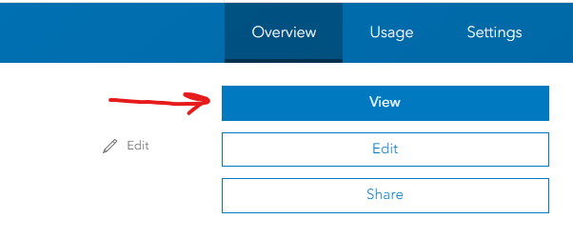
- Return to the content section of your ArcGIS Online page. Select your Experience Builder file. From the details page, click “View.”

Section 3.2 Task (d): Copy the URL of your site and submit it.

